**Lab Pandas Series(Day-25)**

**Lab1: Suppose you are a teacher, and you want to analyze the exam scores of your**

**students in a particular subject. You have recorded the scores of your students for a**

**recent exam, and you want to represent this data using a Pandas Series.**

**Input:**

**students = ['Alice', 'Bob', 'Charlie', 'David', 'Eve', 'Frank', 'Grace', 'Hannah', 'Ivy', 'Jack']**

**exam_scores = [92, 88, 76, 94, 82, 90, 85, 89, 78, 91]**

**Output:**

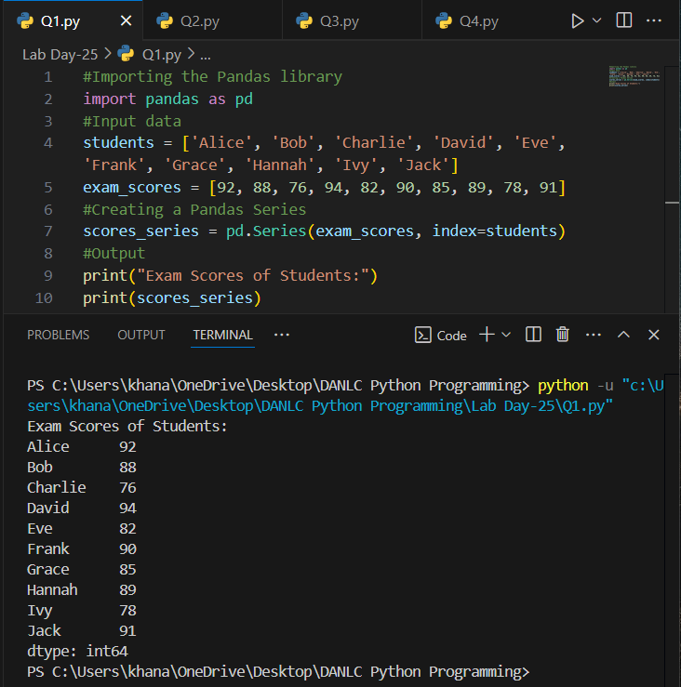

**Lab2: Suppose you want to track and analyze your household expenses for a month.**

**You have recorded the expenses for various categories, such as groceries, utilities, rent,**

**transportation, and entertainment. You can represent this expense data using a Pandas**

**Series.**

**Input:**

**# Expense categories**

**categories = ['Groceries', 'Utilities', 'Rent', 'Transportation', 'Entertainment']**

**# Monthly expense data (example data in USD)**

**expenses = [500, 200, 1200, 300, 150]**

**Output:**

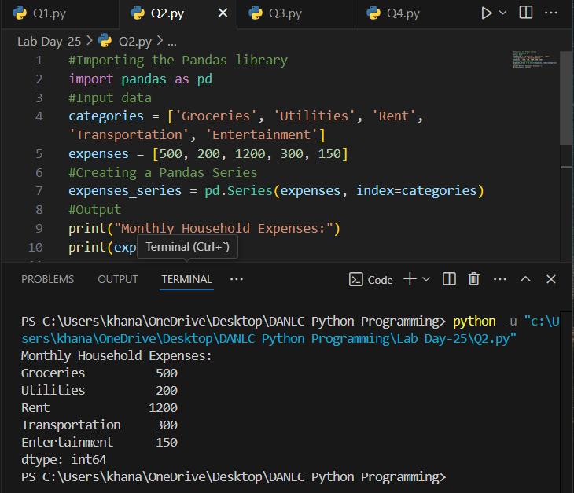

**Lab3: Suppose you want to track and analyze the monthly energy consumption in your**

**home. You have recorded the monthly energy usage for electricity and gas over a year,**

**and you want to represent this data using Pandas Series.**

**Input:**

**# Months in a year**

**months = ['January', 'February', 'March', 'April', 'May', 'June', 'July', 'August',**

**'September', 'October', 'November', 'December']**

**# Monthly energy consumption data (example data in kilowatt-hours for electricity and**

**therms for gas)**

**electricity_usage = [350, 320, 310, 330, 340, 370, 380, 360, 350, 330, 320, 330]**

**gas_usage = [20, 18, 16, 15, 12, 10, 8, 9, 12, 15, 17, 19]**

**Output:**

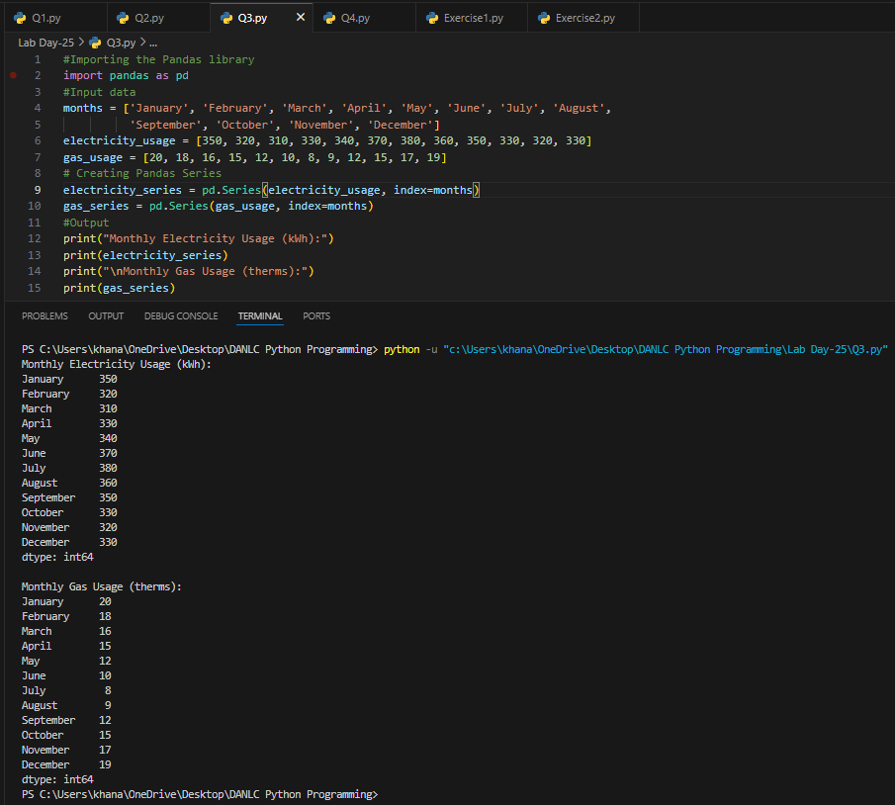

**Lab4:Suppose you are managing a website and want to analyze the monthly revenue**

**generated from advertising. You have recorded the monthly revenue for the past year,**

**and you want to represent this data using a Pandas Series.**

**Input:**

**# Months in a year**

**months = ['January', 'February', 'March', 'April', 'May', 'June', 'July', 'August',**

**'September', 'October', 'November', 'December']**

**# Monthly advertising revenue data (example data in USD)**

**revenue = [5000, 5200, 4800, 5400, 5600, 5800, 6100, 5900, 6200, 6500, 7000, 6900]**

**Output:**

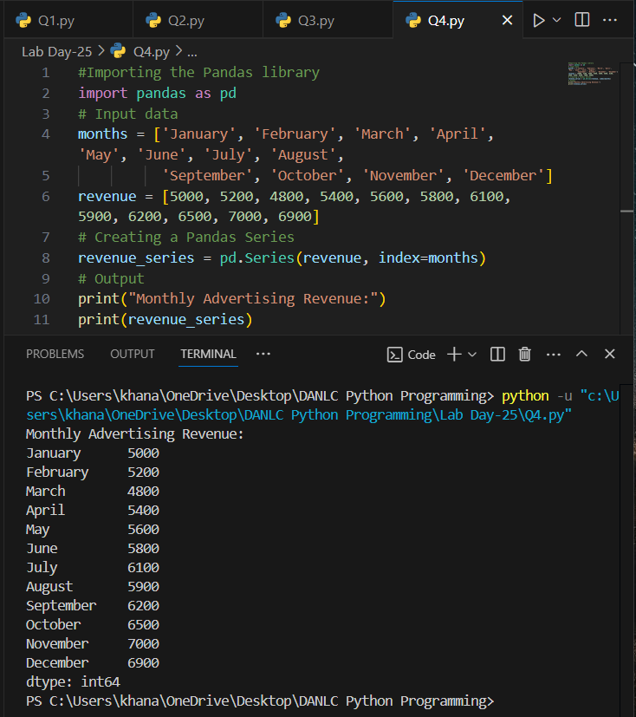

**Using ChatGPT generate the python code to solve the same problem**

**Hi! I have two columns with some dummy value. I want to create a line plot of the**

**opening, closing stock prices of SBI between two specific dates using a pandas**

**plot.Can you generate a complete code for me?**

**After generating the code using chatgpt, run the code, display the output and give your**

**conclusion.**

**Output:**

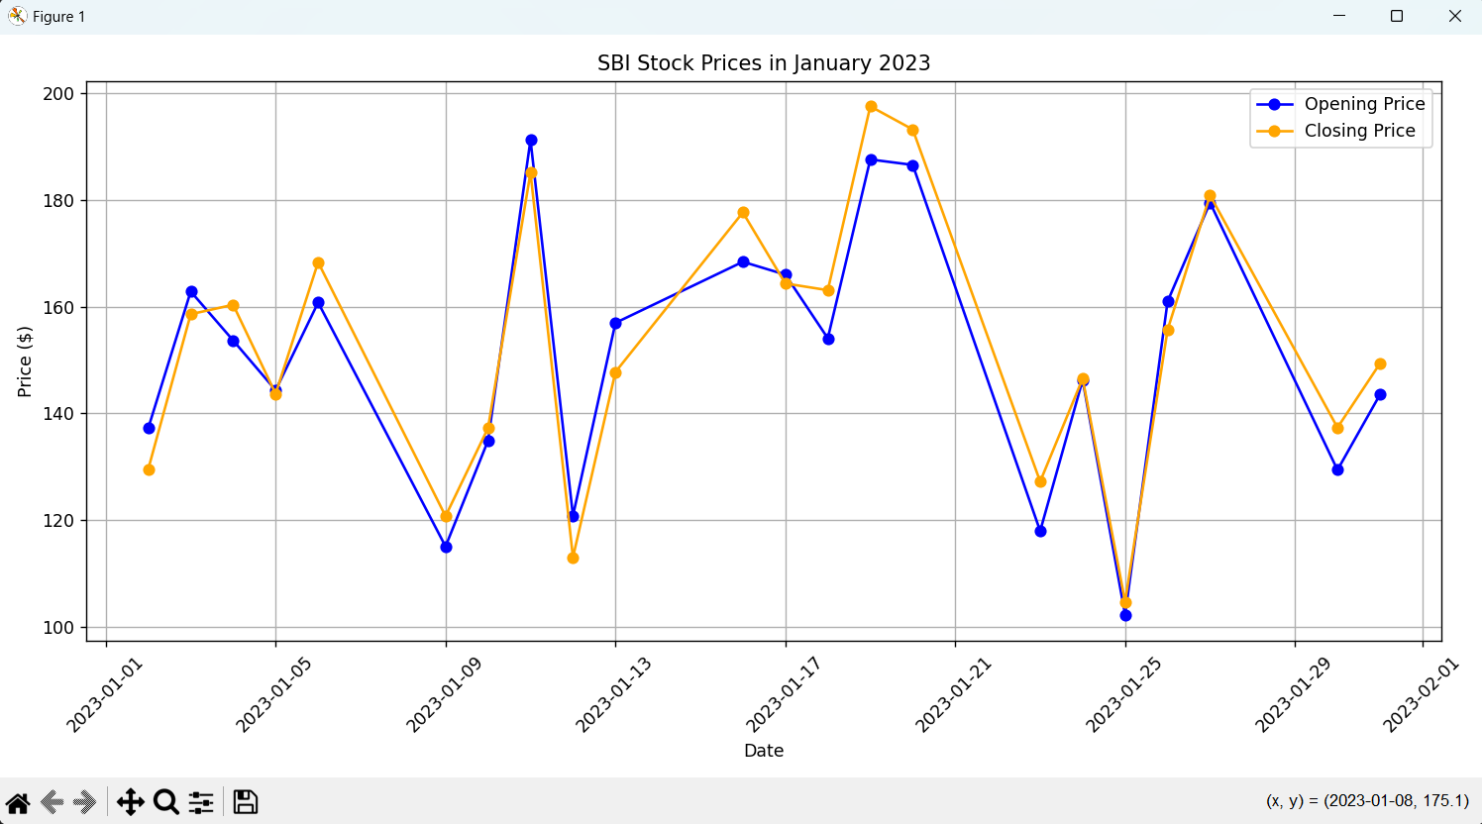

**ChatGPT Exercise**

**Using ChatGPT generate the python code to solve the same problem**

**Scenario: Analyzing Stock Prices**

**Suppose you are an investor interested in analyzing the stock prices of a particular**

**company over a year. You have collected daily closing prices for that company's stock,**

**and you want to perform some analysis like Calculate the average daily return,Find the**

**date with the highest closing price and also generate a line chart using Pandas Series.**

**Further, you need to get some inference out of the chart.**

**Create a ChatGPT prompt to generate the code for this scenario. Based on the code**

**generated, ask ChatGPT to give the conclusion/inference.**

**Note. You can provide the data to ChatGPT in the form of a list or dictionary or ask it to use sample data.**

**Output:**

